**Welcome to "Clocked by Jerry"**

A one-of-a-kind online shop showcasing exclusive vintage-style cuckoo clocks inspired by the timeless antics of *Tom and Jerry*. Our carefully curated collection features charming and unique designs that capture the playful essence of the beloved cartoon, from whimsical chases and mischievous pranks to hilarious escapes that have delighted audiences for generations. Explore a wide variety of designs, including limited editions and rare finds that celebrate the spirit of cat-and-mouse mischief. Whether you're reliving childhood memories or adding a whimsical centerpiece to your décor, our *Tom and Jerry*-inspired cuckoo clocks are a timeless way to keep the fun alive.

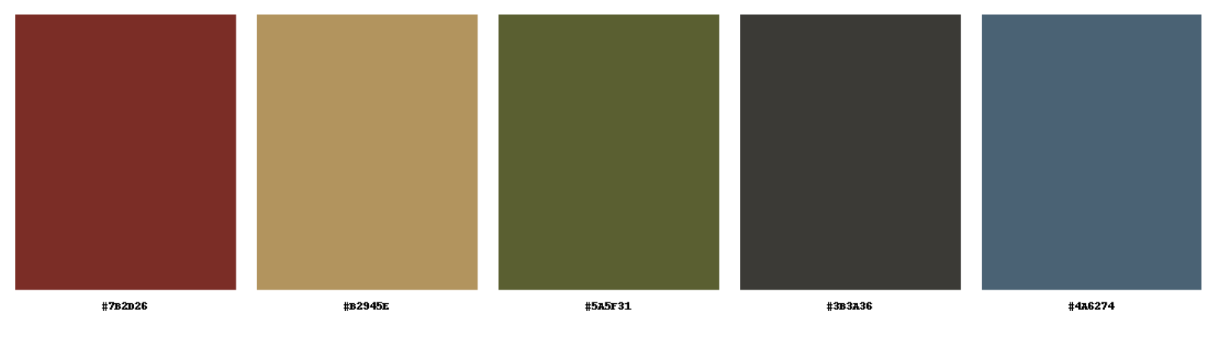

| **Hex Code: #7B2D2D** | **Hex Code: #9B8250** | **Hex Code: #4E532A** | **Hex Code: #3B3A36** | **Hex Code: #4A6274** |
| --- | --- | --- | --- | --- |

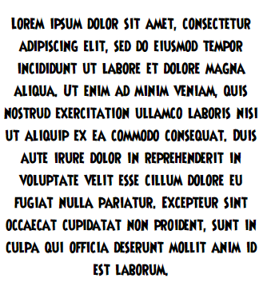

*TYPOGRAPHY*





Logo Designs

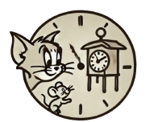

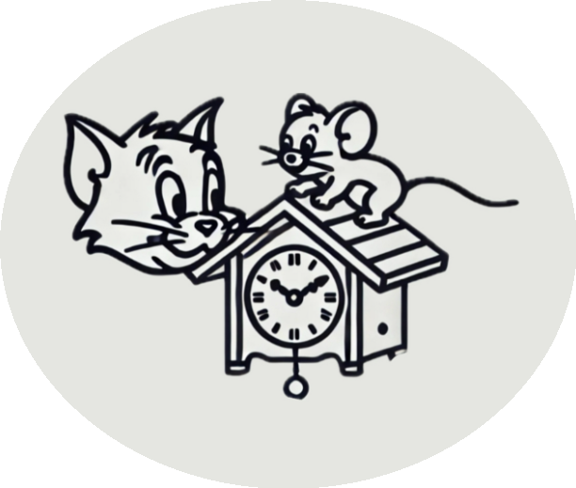

Sample Pictures

| CITATION TYPE | APA CITATION SOURCE | IMAGE |
| --- | --- | --- |
| Public Domain | https://m.imdb.com/title/tt1136570/mediaviewer/rm2932107520/ |  |
| Public Domain | [https://www.facebook.com/100043007932429/videos/tom-and-jerry-cartoon/306692747499661](https://www.facebook.com/100043007932429/videos/tom-and-jerry-cartoon/306692747499661/) |  |
| Public Domain | <https://www.dailymotion.com/video/x191dxm> |  |
| Public Domain | <https://www.facebook.com/groups/classiclooneytunes/posts/926426672426119/?_rdr> |  |
| Public Domain | <https://www.imdb.com/title/tt9626396/> |  |
| Public Domain | https://tv.apple.com/us/episode/ballad-of-the-catnip-kid/umc.cmc.4uqx9xzh5oou7569w7ks19wn4?showId=umc.cmc.lp3650yukr4v04mst6woojrl |  |
| Public Domain | https://www.imdb.com/title/tt9626396/mediaviewer/rm3411700225/?ref_=tt_ph_1_1 |  |
| Public Domain | https://www.pngkey.com/maxpic/u2q8a9o0y3u2o0a9/ |  |